# **OPTIMISING THE EFFICACY OF TIME-LIMITED INTERVENTIONS FOR EPIDEMIC CONTROL**

## **SUPPLEMENTARY MATERIAL**

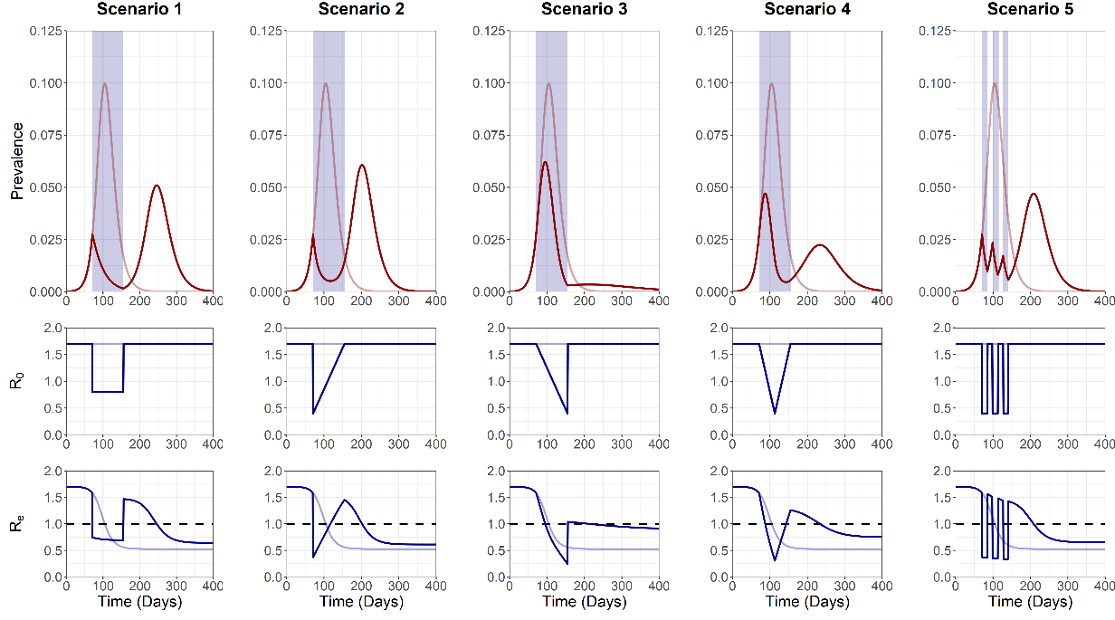

**Figure S1 - ALTERNATIVE METHOD FOR SINGLE INTERVENTION**

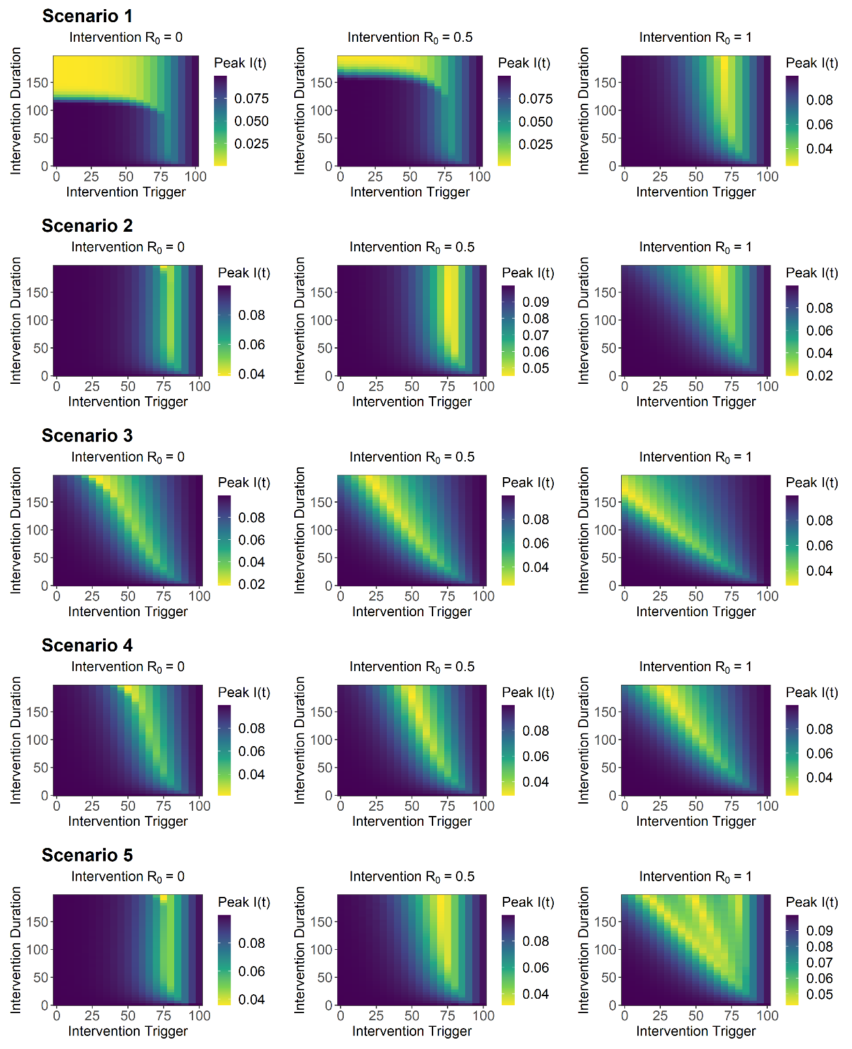

**Figure S2– R0 SENSITIVITY ANALYSIS (I(T) PEAK)**

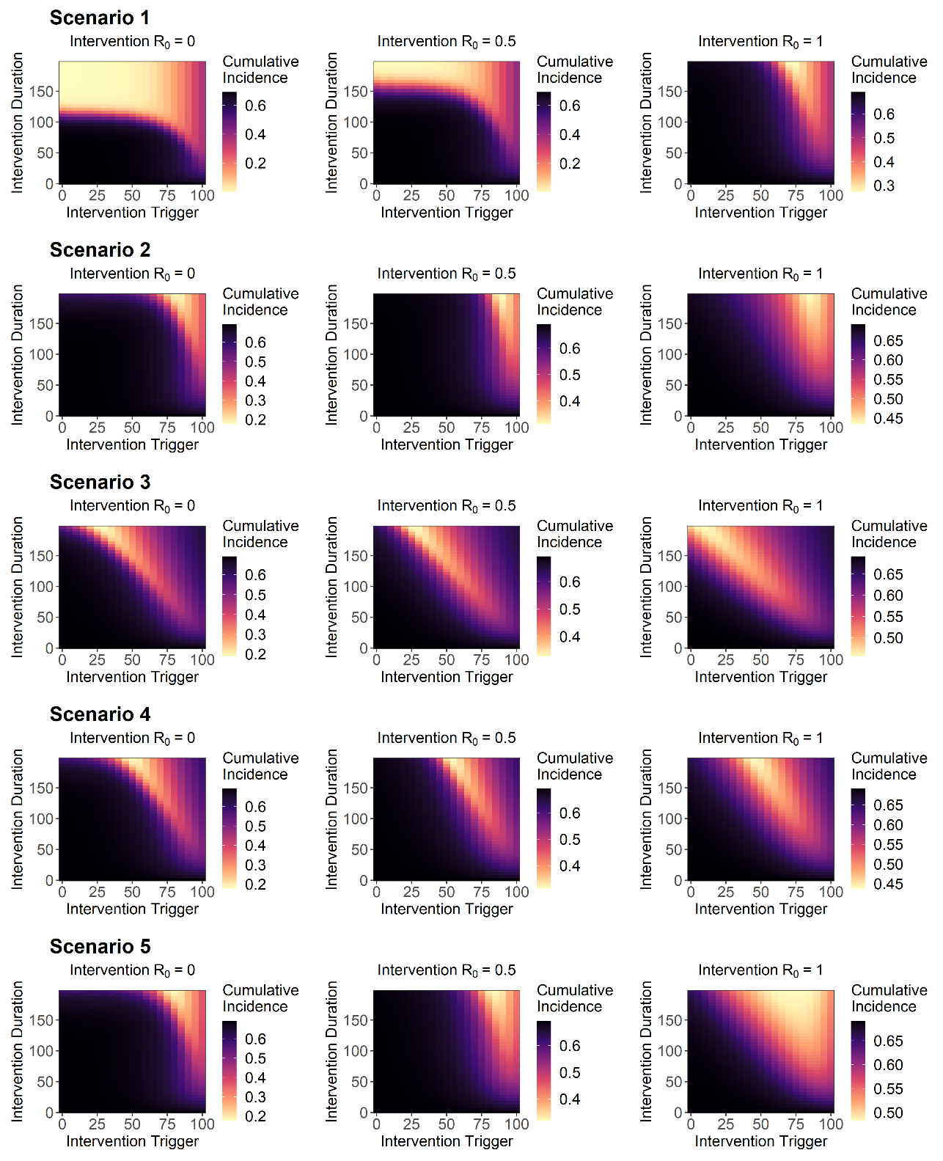

**Figure S3 – IN PROGRESS – R0 SENSITIVITY ANALYSIS (CUMULATIVE)**

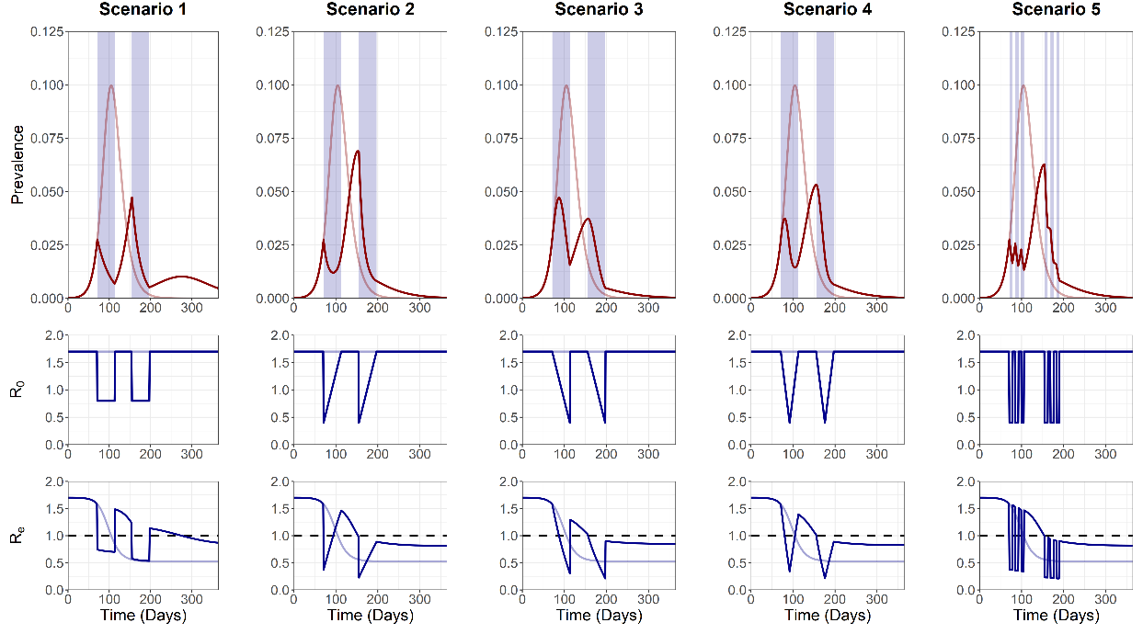

**Figure S4 – ALTERNATIVE METHOD FOR REPEATED INTERVENTION**

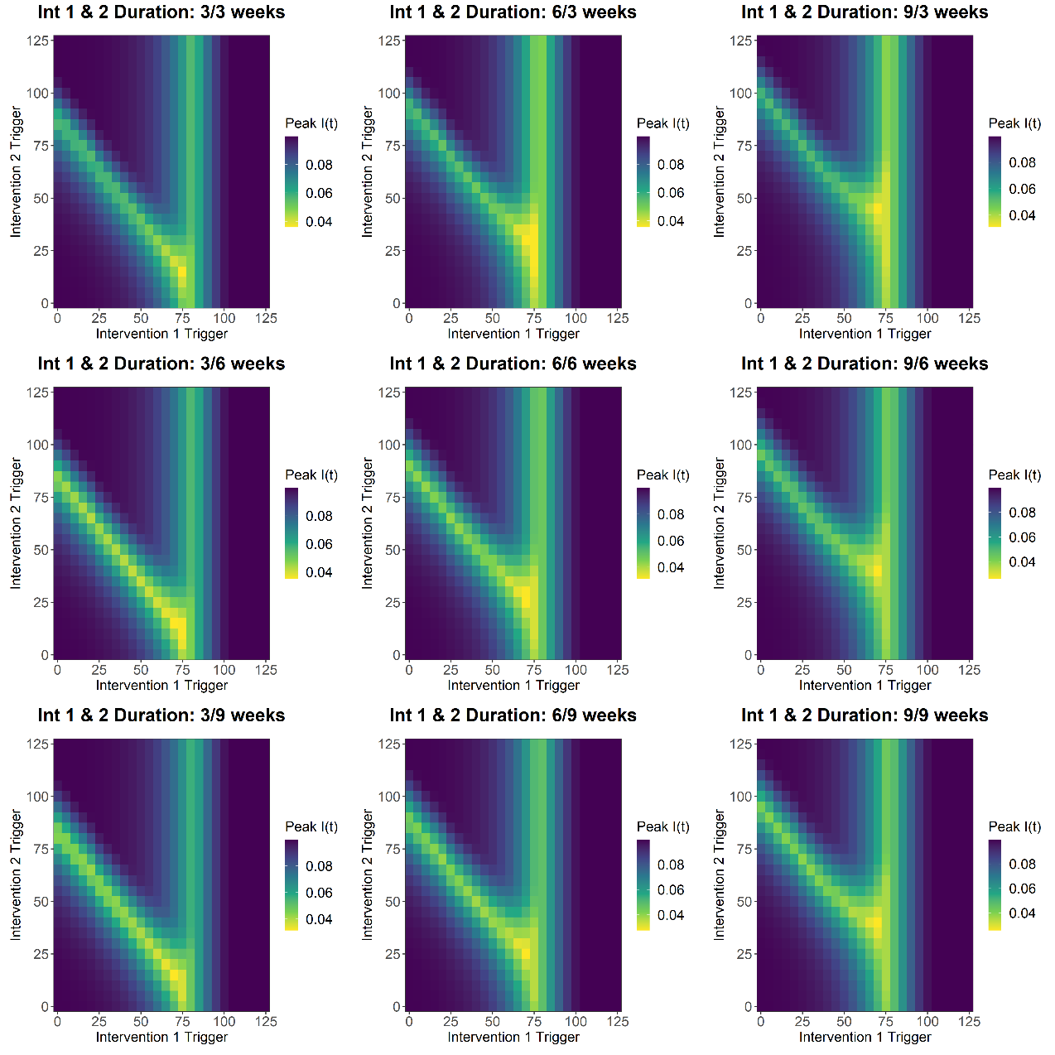

**Figure S5 – SCENARIO 1 PEAK I(T)**

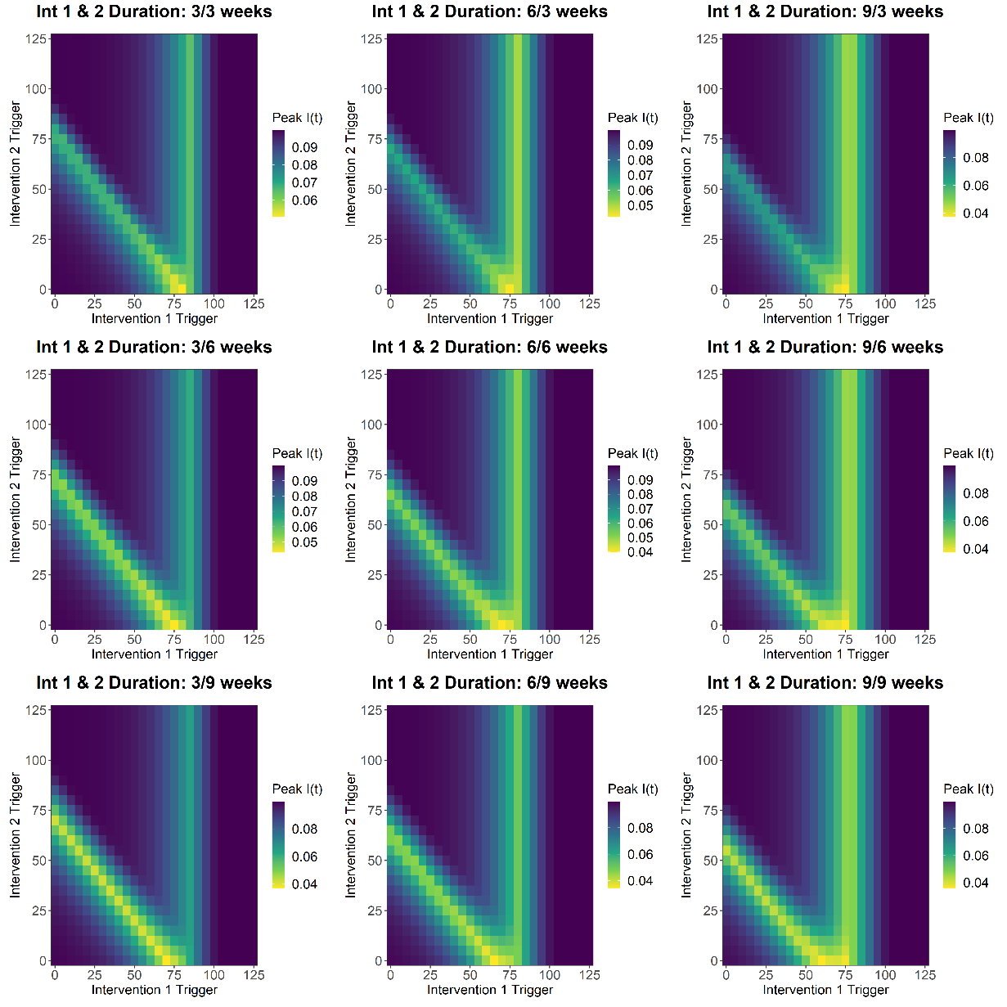

**Figure S6 – SCENARIO 2 PEAK I(T)**

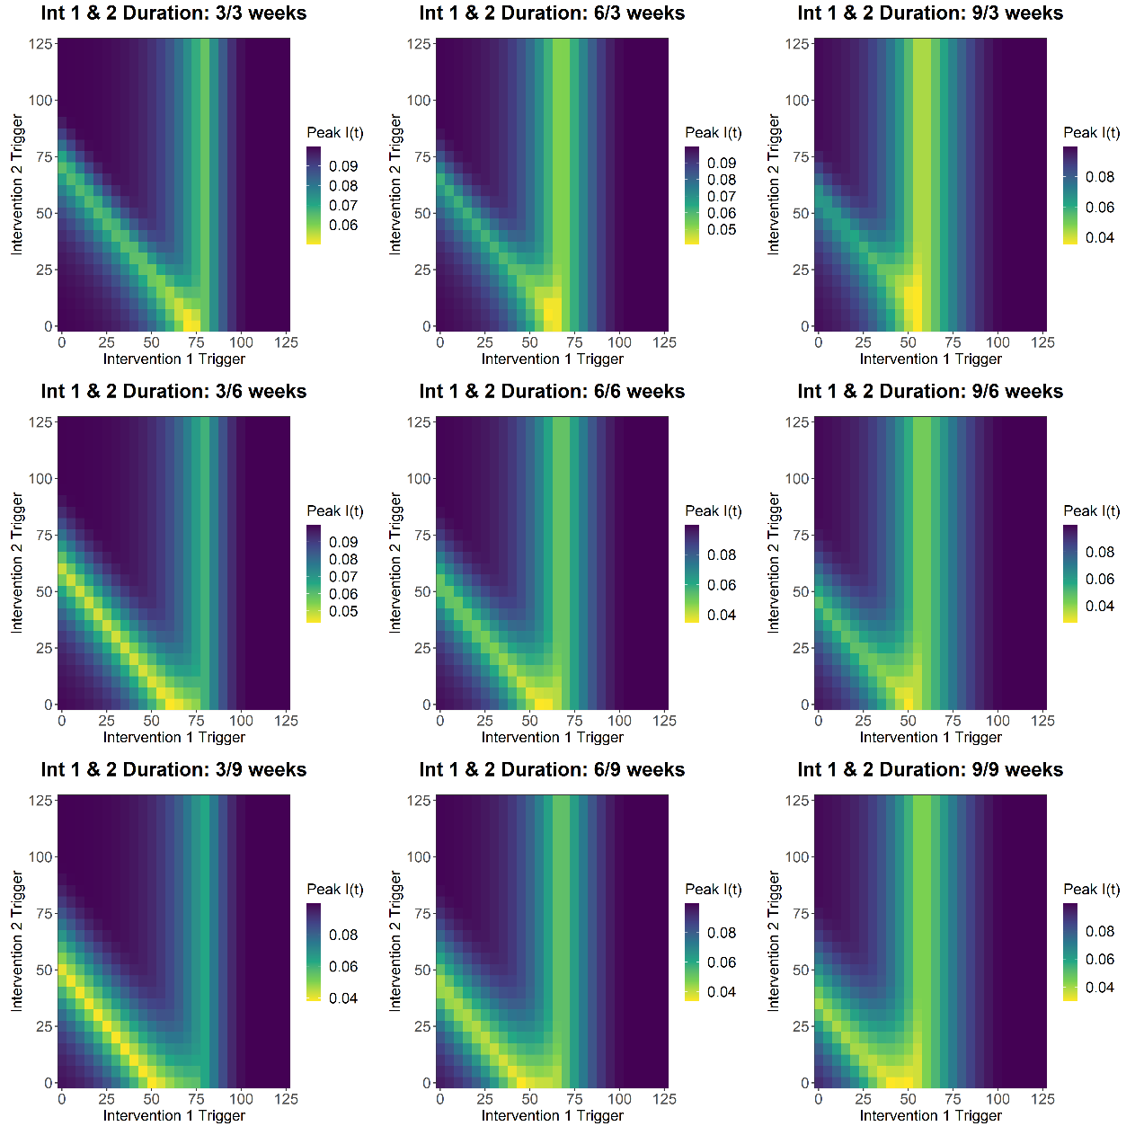

**Figure S7 – SCENARIO 3 PEAK I(T)**

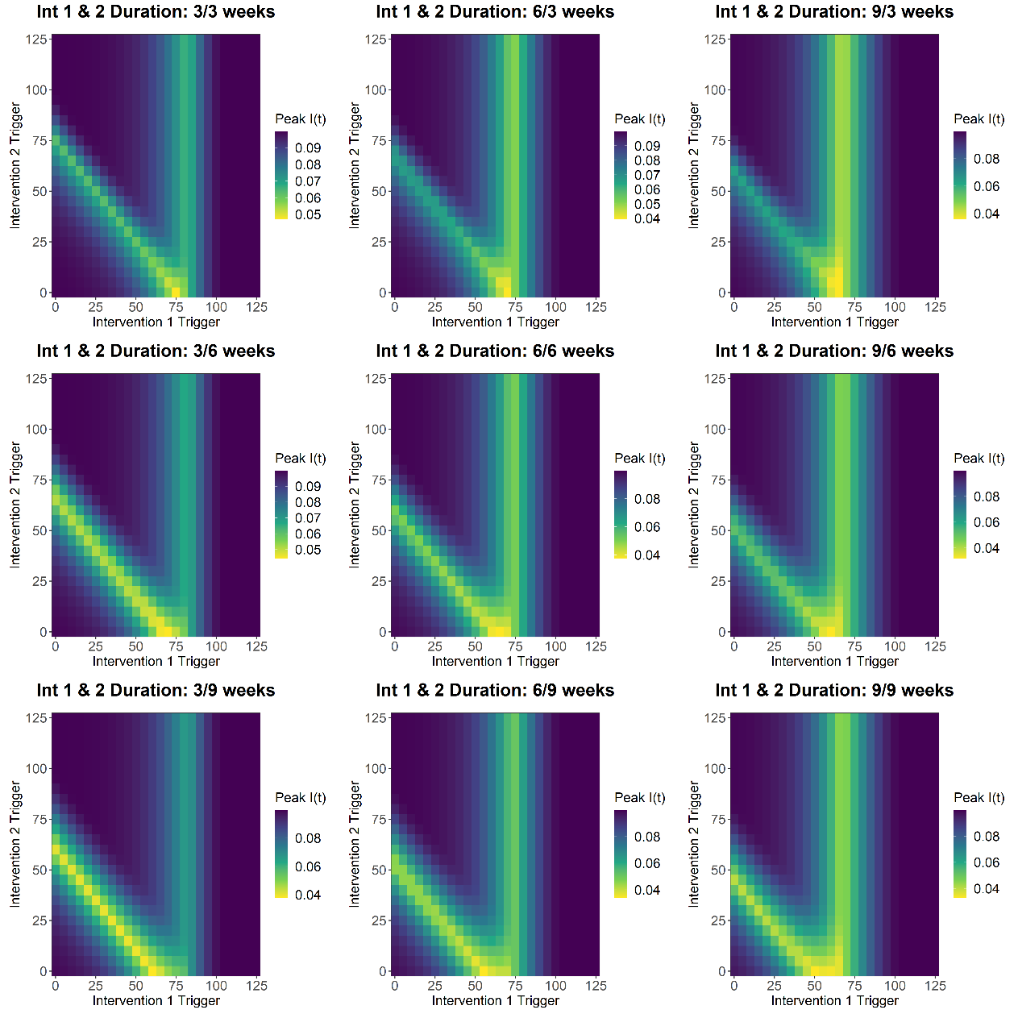

**FIGURE S8 - SCENARIO 4 PEAK I(T)**

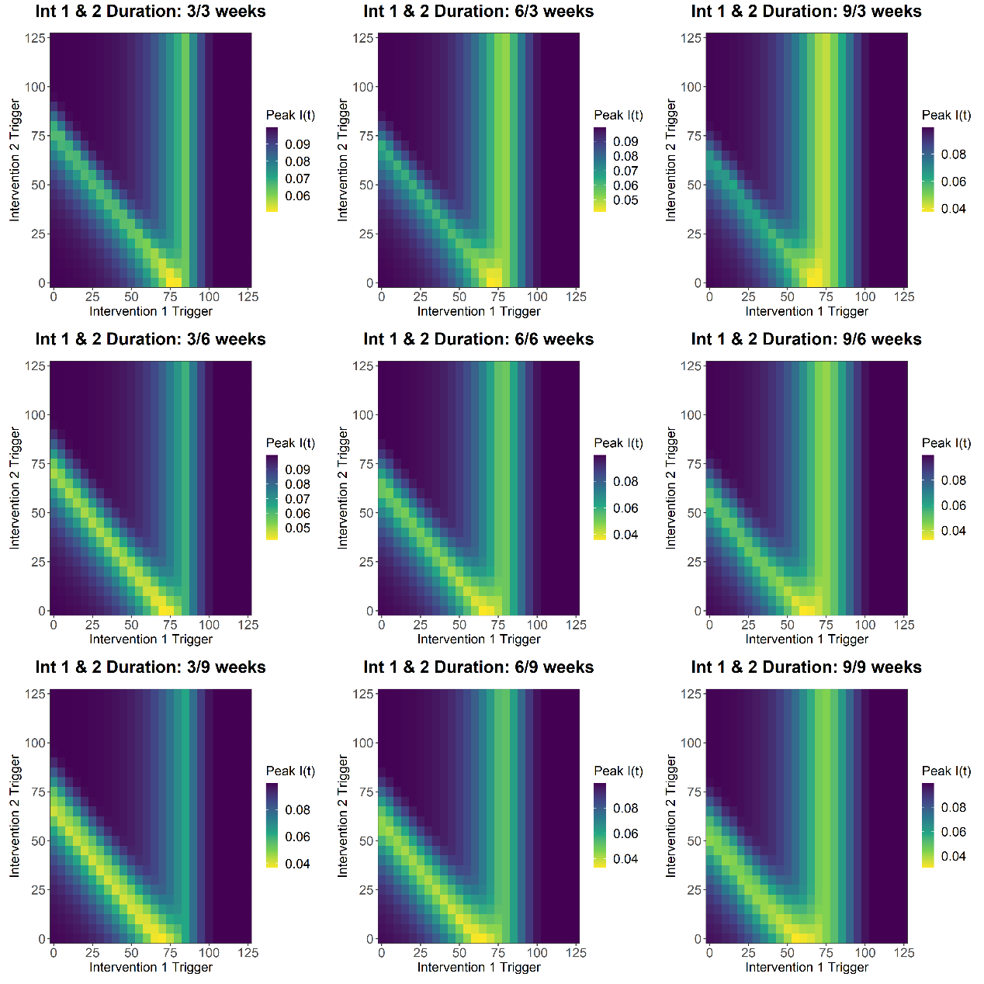

**FIGURE S9 - SCENARIO 5 PEAK I(T)**

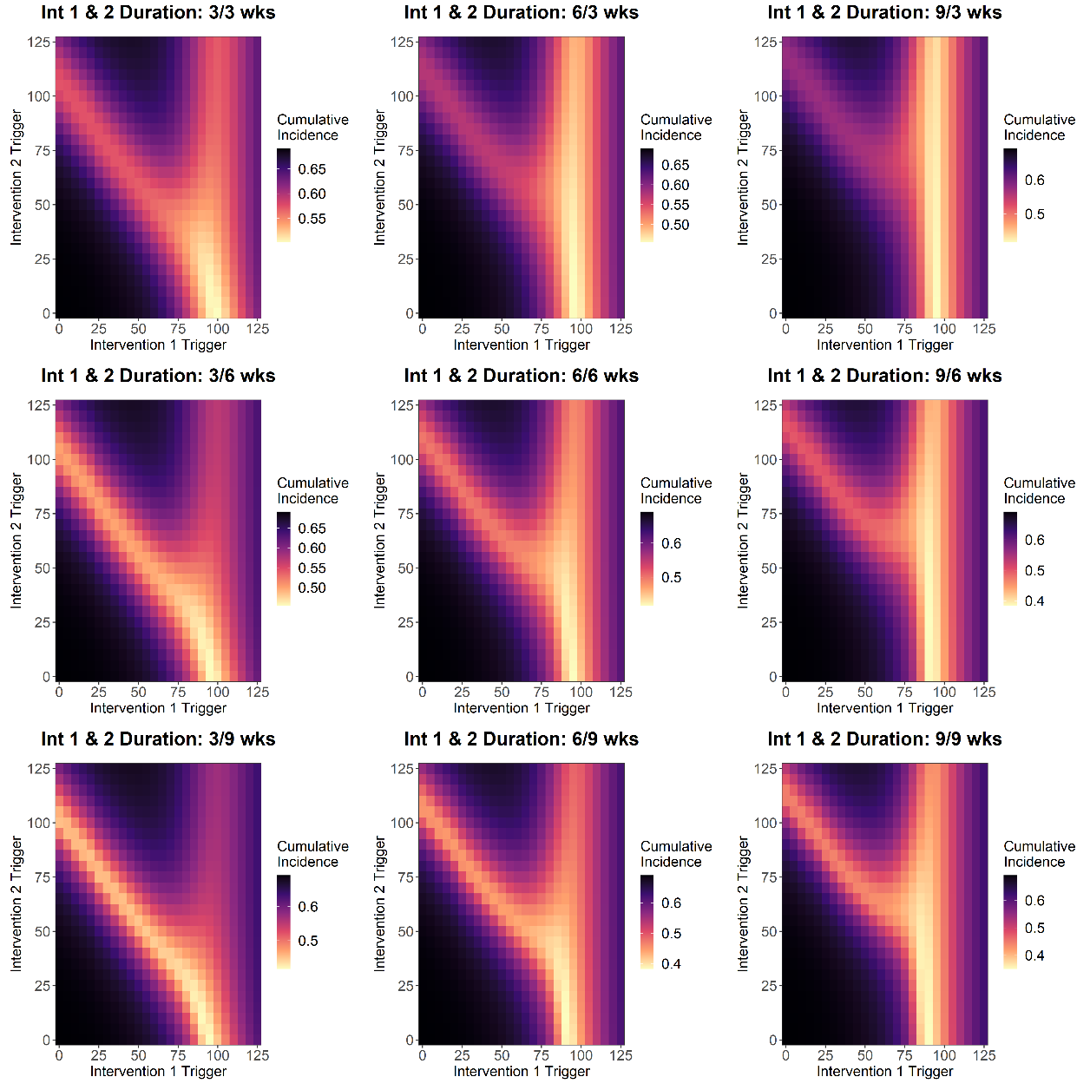

**FIGURE S10 - SCENARIO 1 TOTAL CUMULATIVE INCIDENCE**

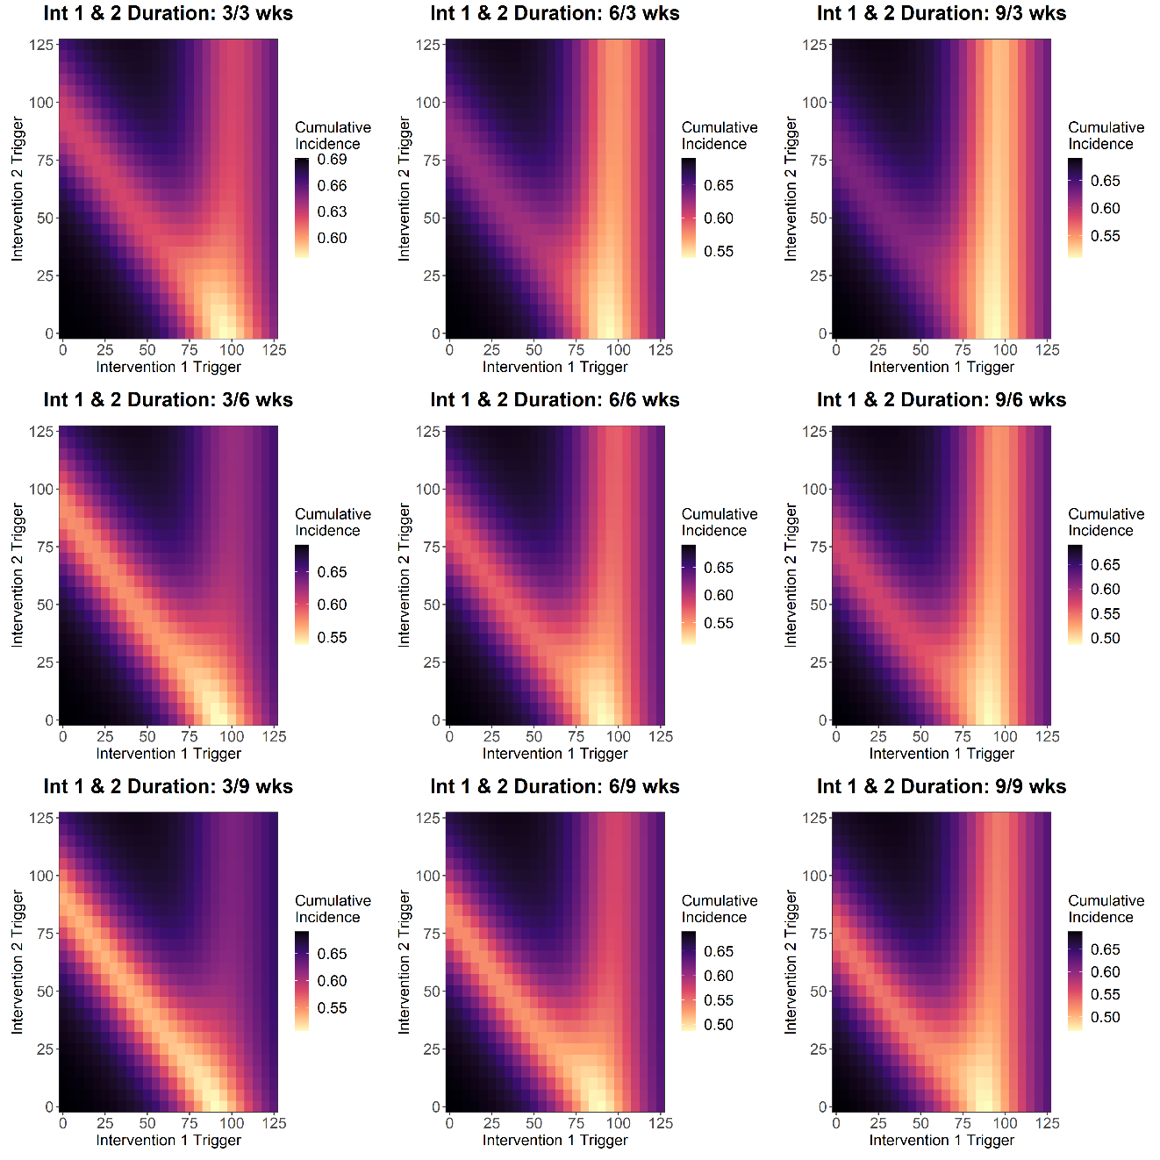

**FIGURE S11 - SCENARIO 2 TOTAL CUMULATIVE INCIDENCE**

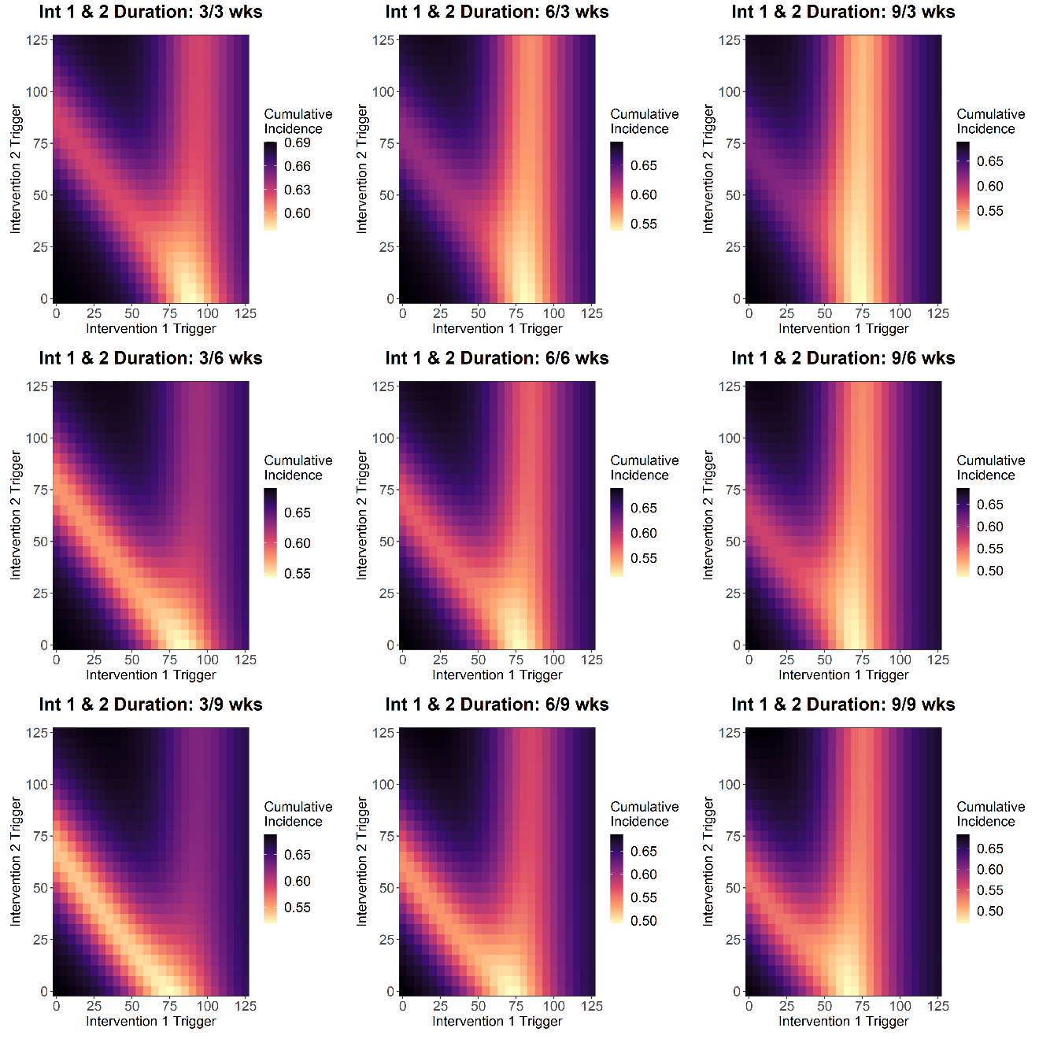

**FIGURE S12 - SCENARIO 3 TOTAL CUMULATIVE INCIDENCE**

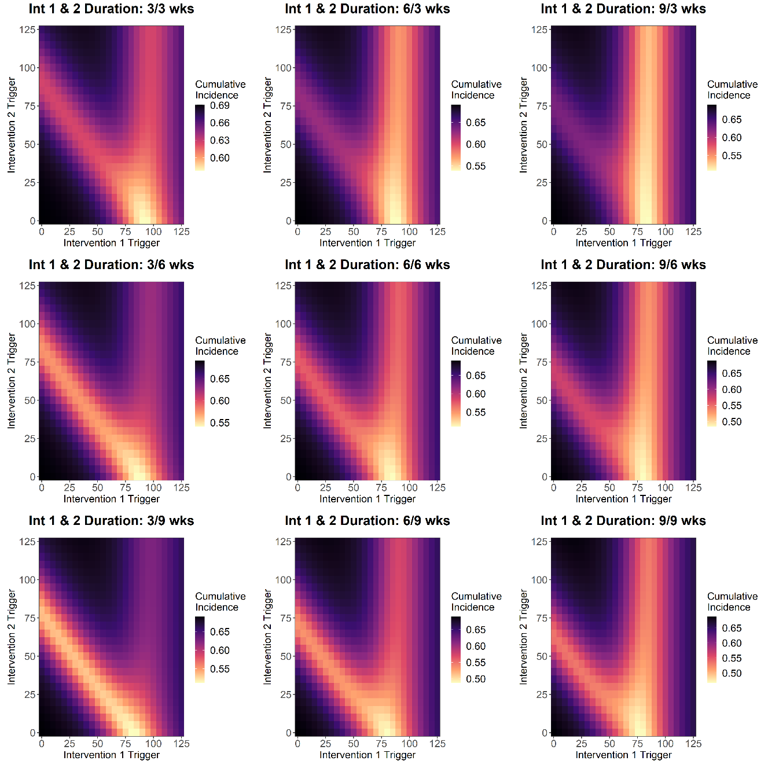

**FIGURE S13 - SCENARIO 4 TOTAL CUMULATIVE INCIDENCE**

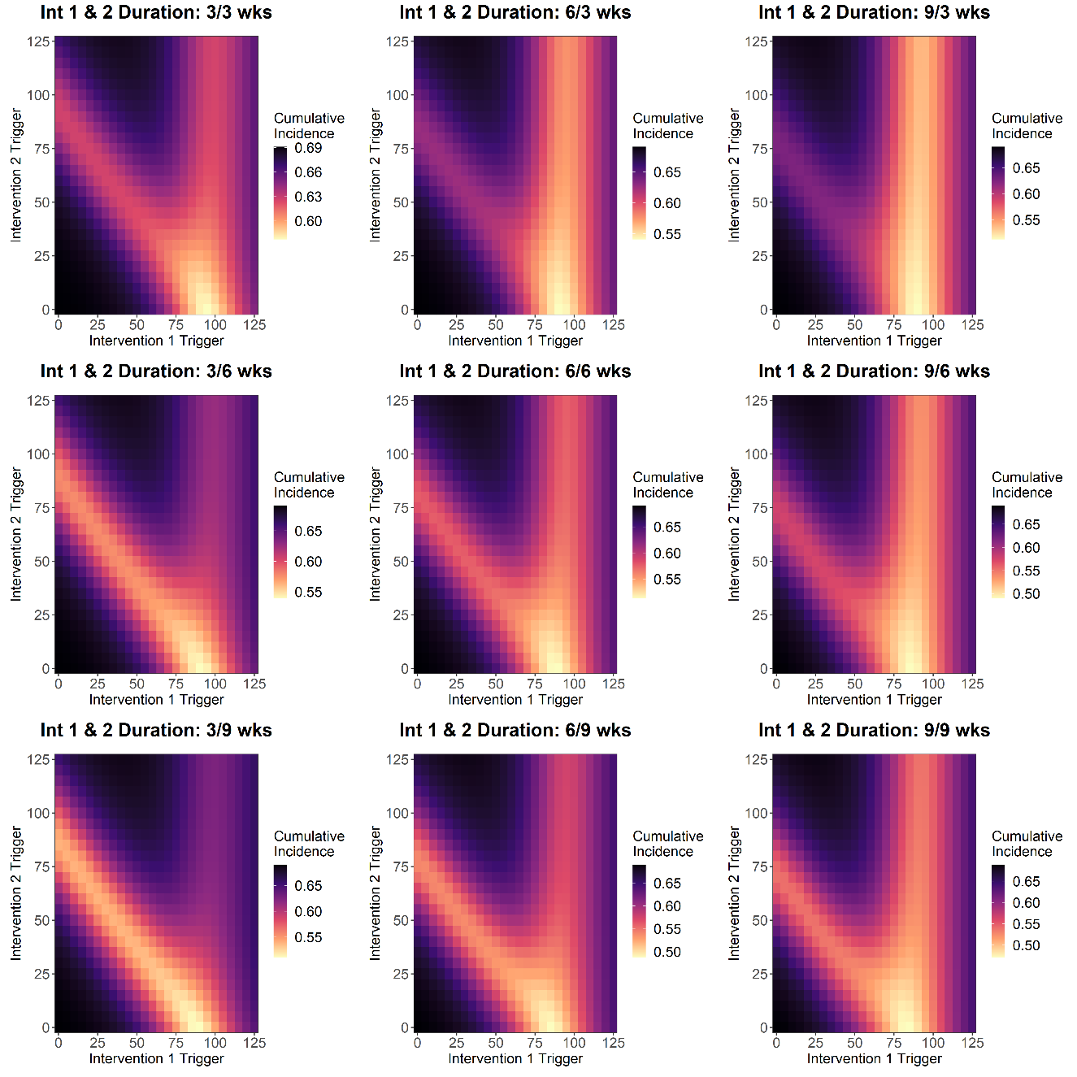

**FIGURE S14 - SCENARIO 5 TOTAL CUMULATIVE INCIDENCE**

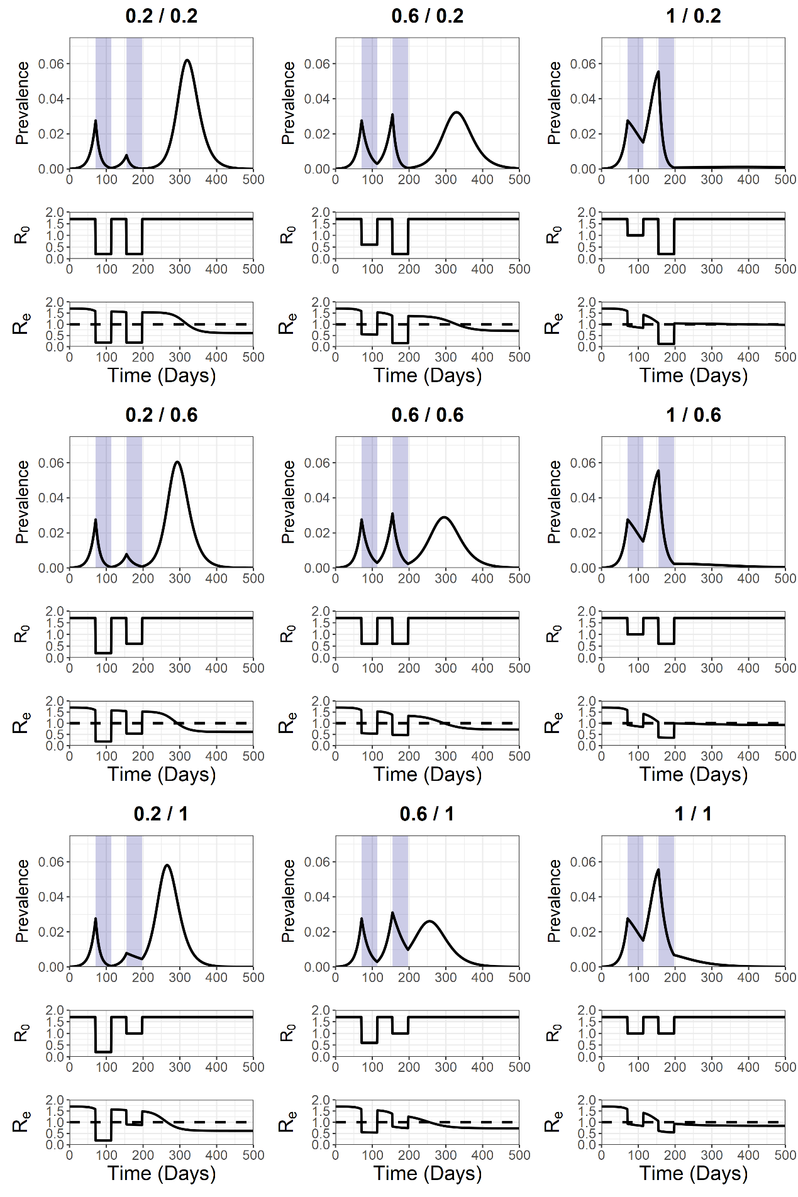

**FIGURE S15 - SCENARIO 1 TRAJECTORY PLOT R0 SENSITIVITY ANALYSIS TO INT 1 + INT 2 R0**

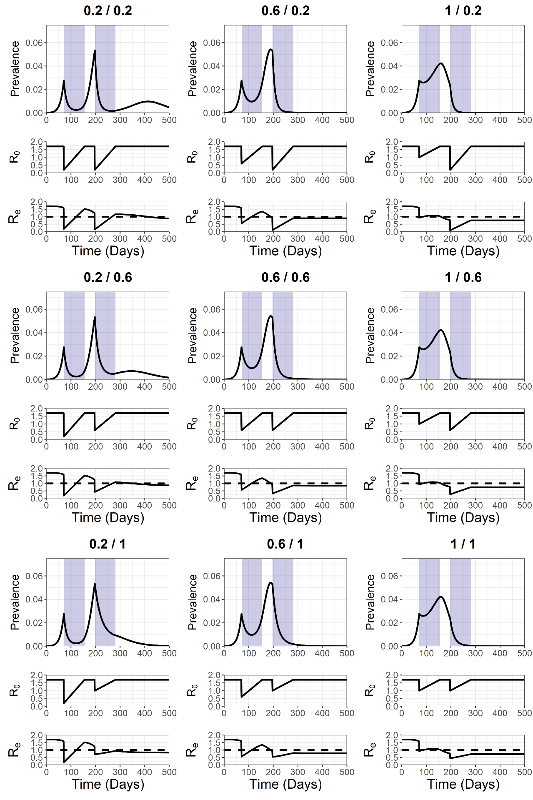

**FIGURE S16 - SCENARIO 2 TRAJECTORY PLOT R0 SENSITIVITY ANALYSIS TO INT 1 + INT 2 R0**

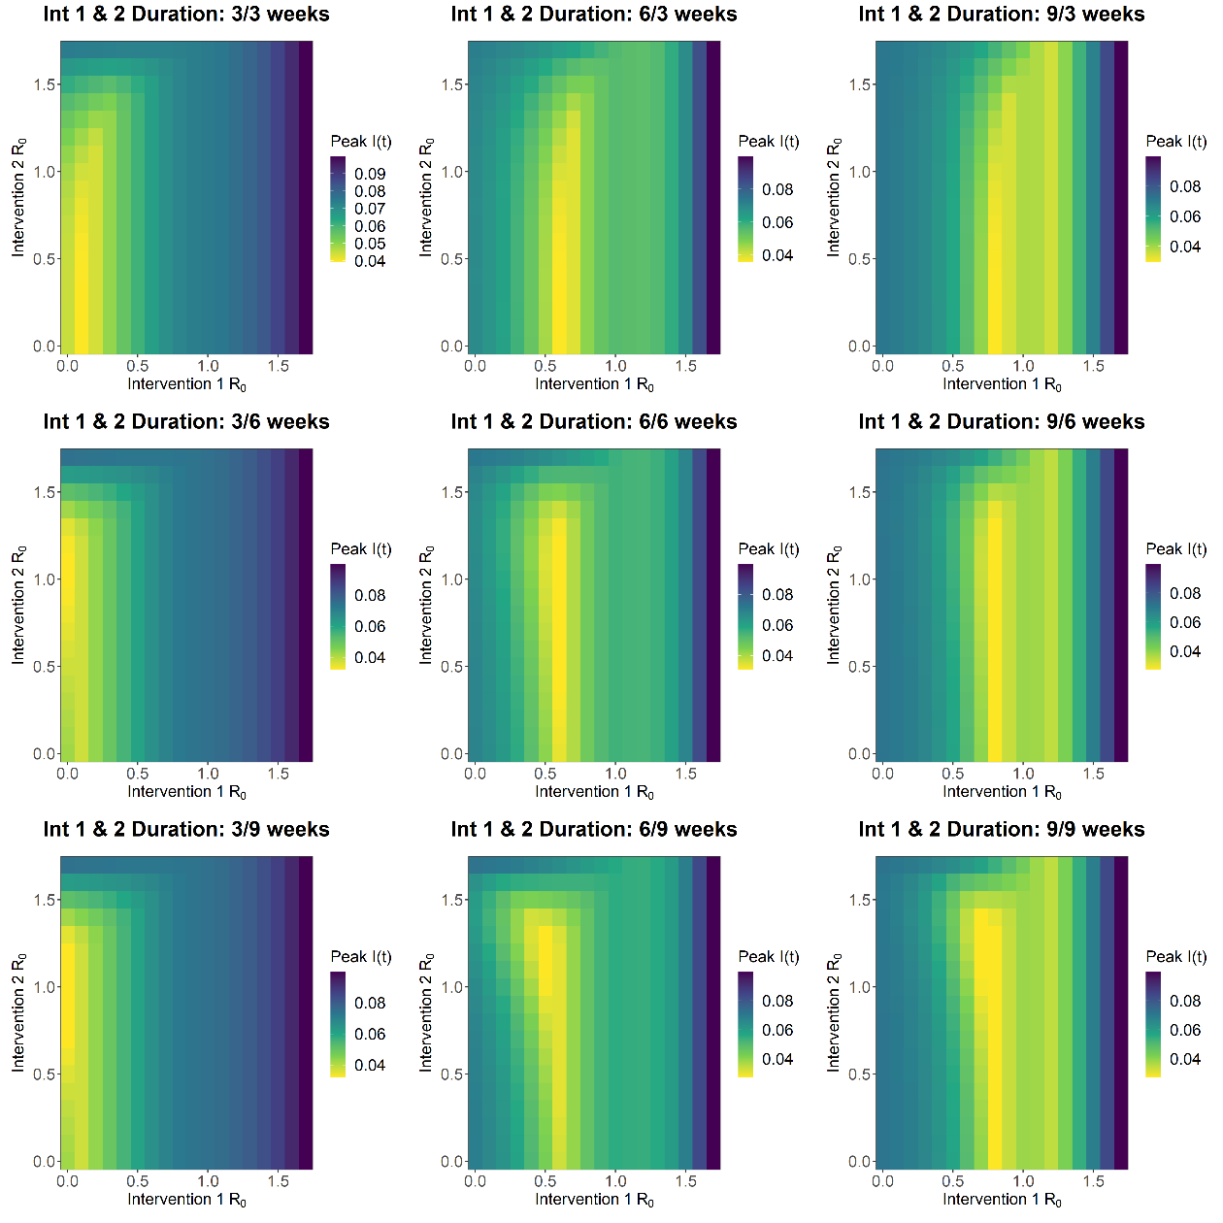

**FIGURE S17 - SCENARIO 1 PEAK I(T)**

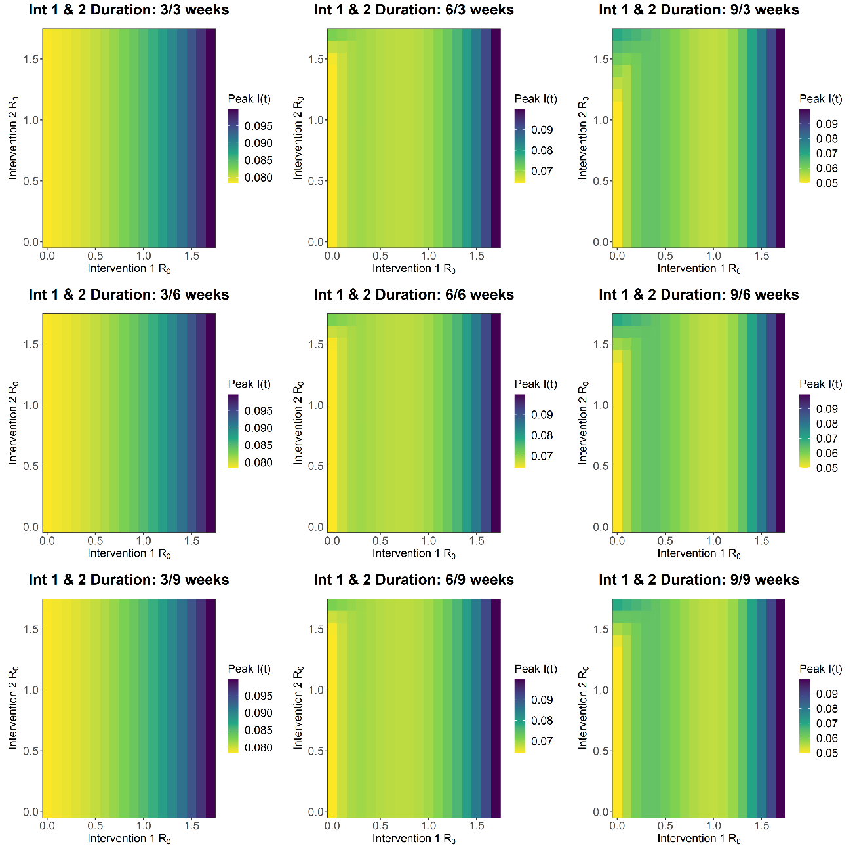**FIGURE S18 - SCENARIO 2 PEAK I(T)**

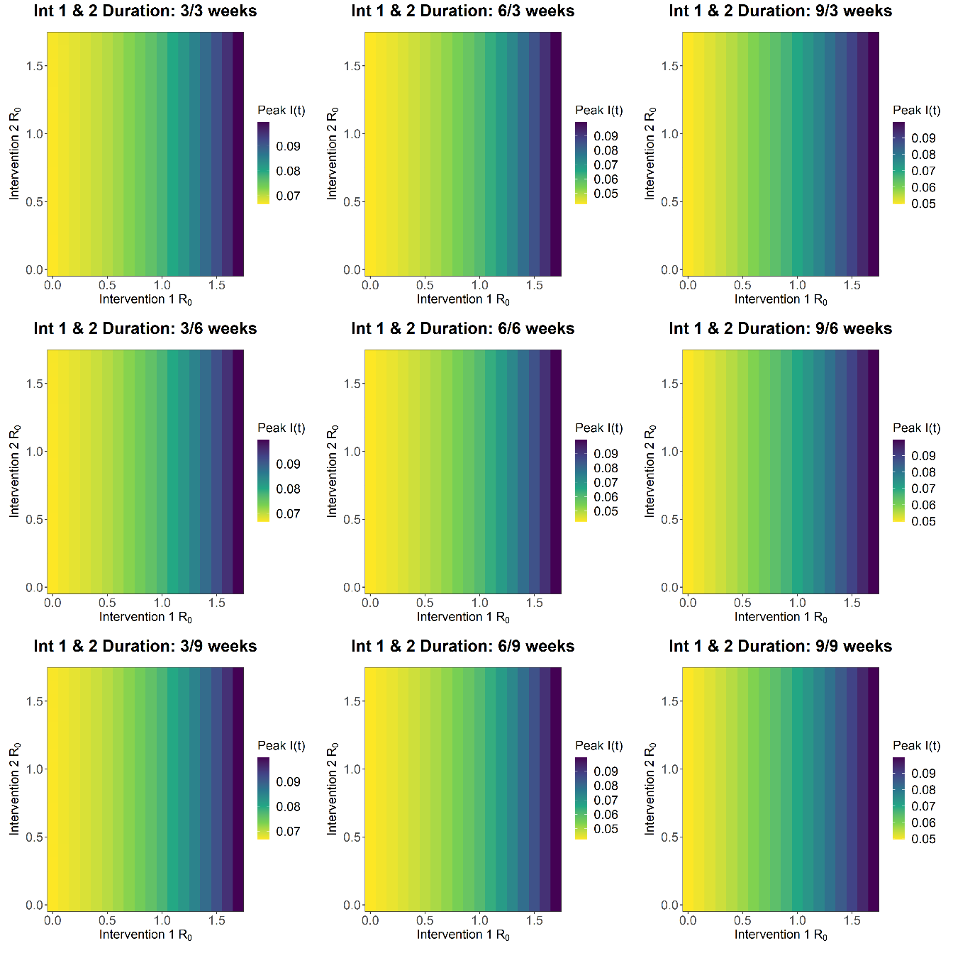

**FIGURE S19 - SCENARIO 3 PEAK I(T)**

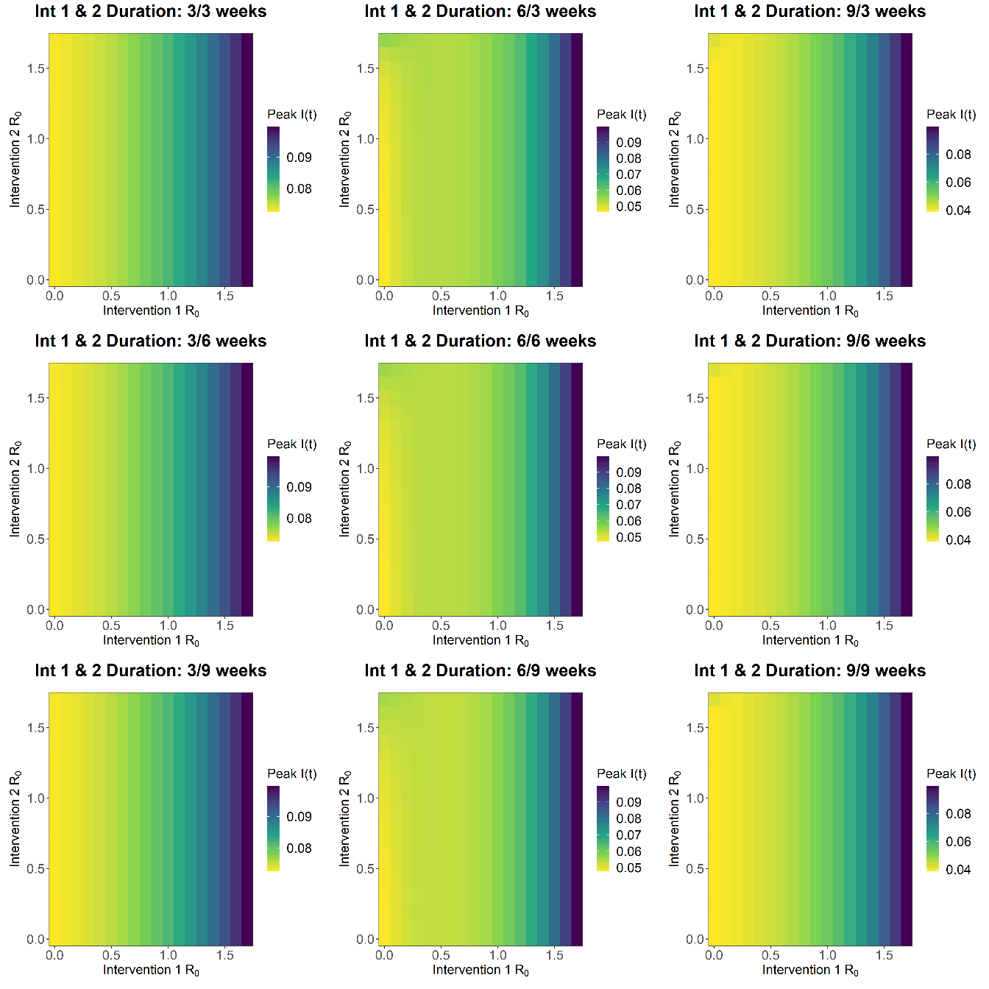

**FIGURE S20 - SCENARIO 4 PEAK I(T)**

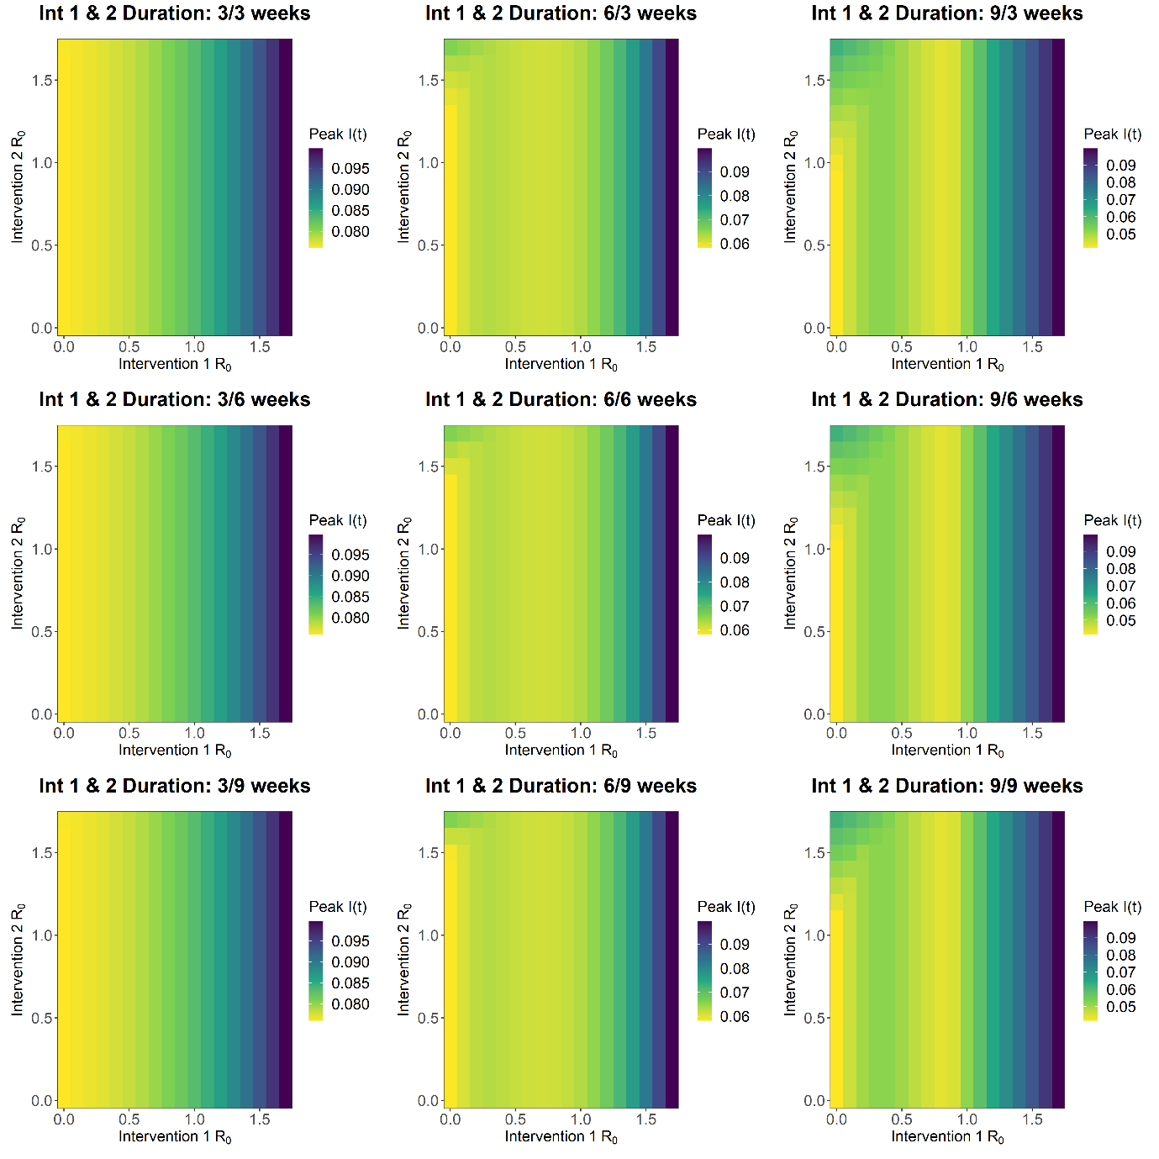

**FIGURE S21 - SCENARIO 5 PEAK I(T)**

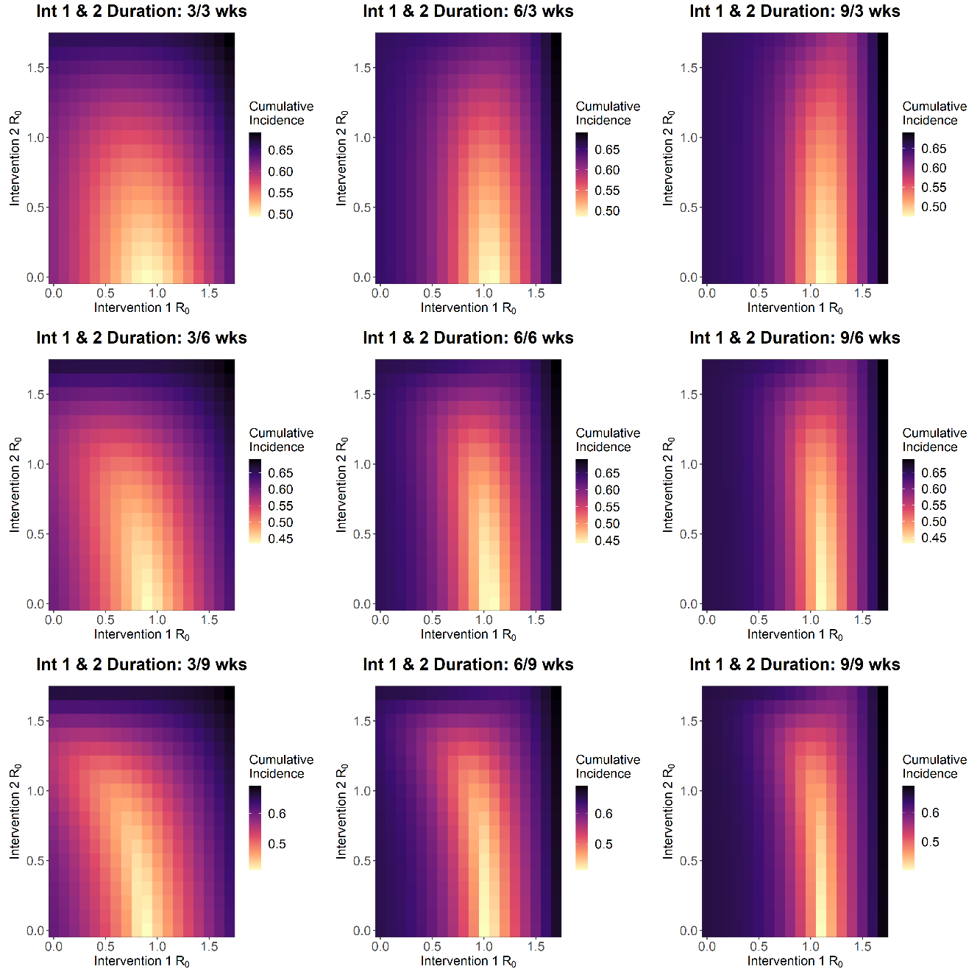

**FIGURE S22 - SCENARIO 1 TOTAL CUMULATIVE INCIDENCE**

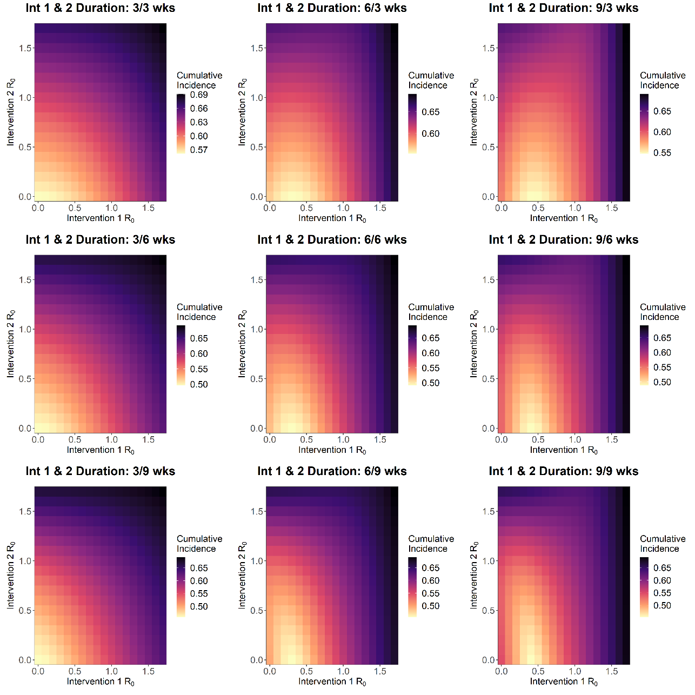

**FIGURE S23 - SCENARIO 2 TOTAL CUMULATIVE INCIDENCE**

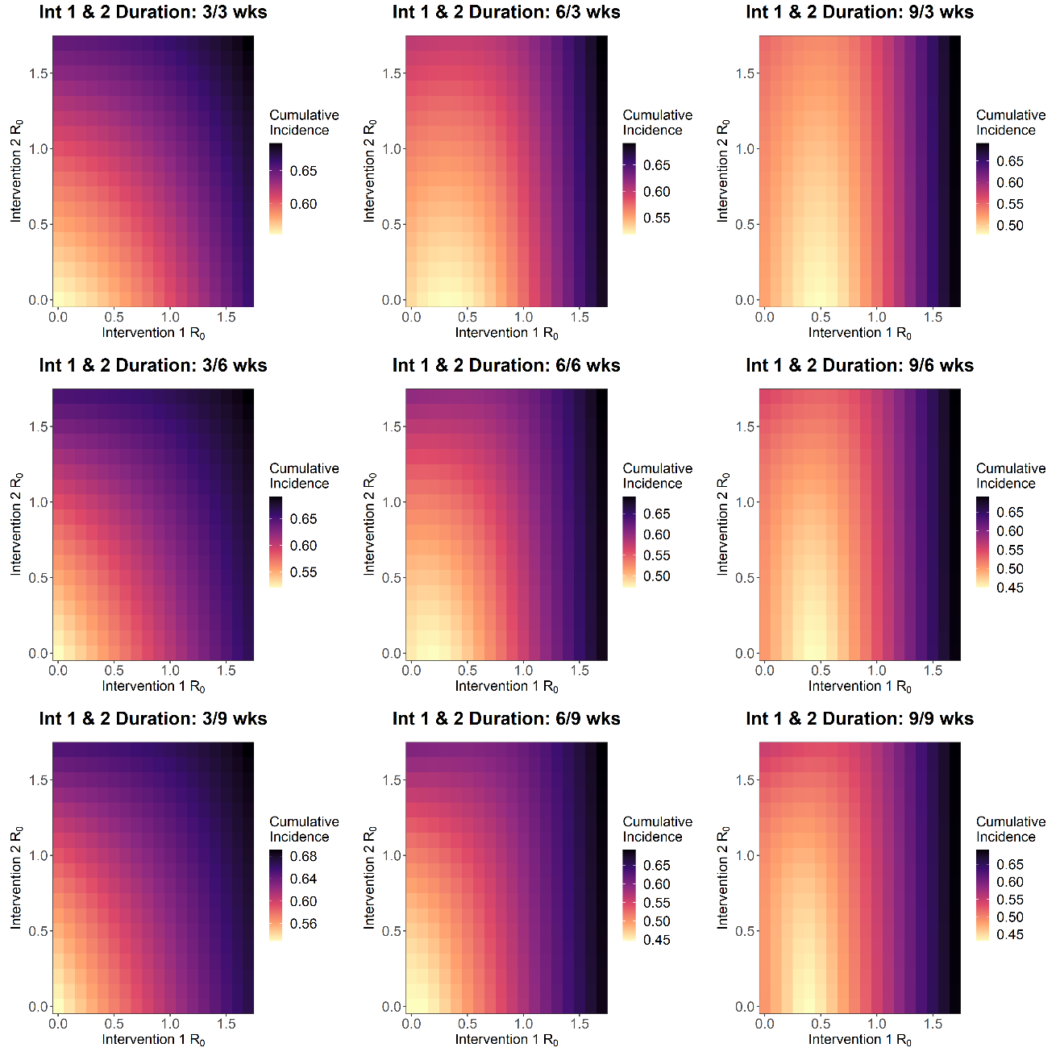

**FIGURE S24 - SCENARIO 3 TOTAL CUMULATIVE INCIDENCE**

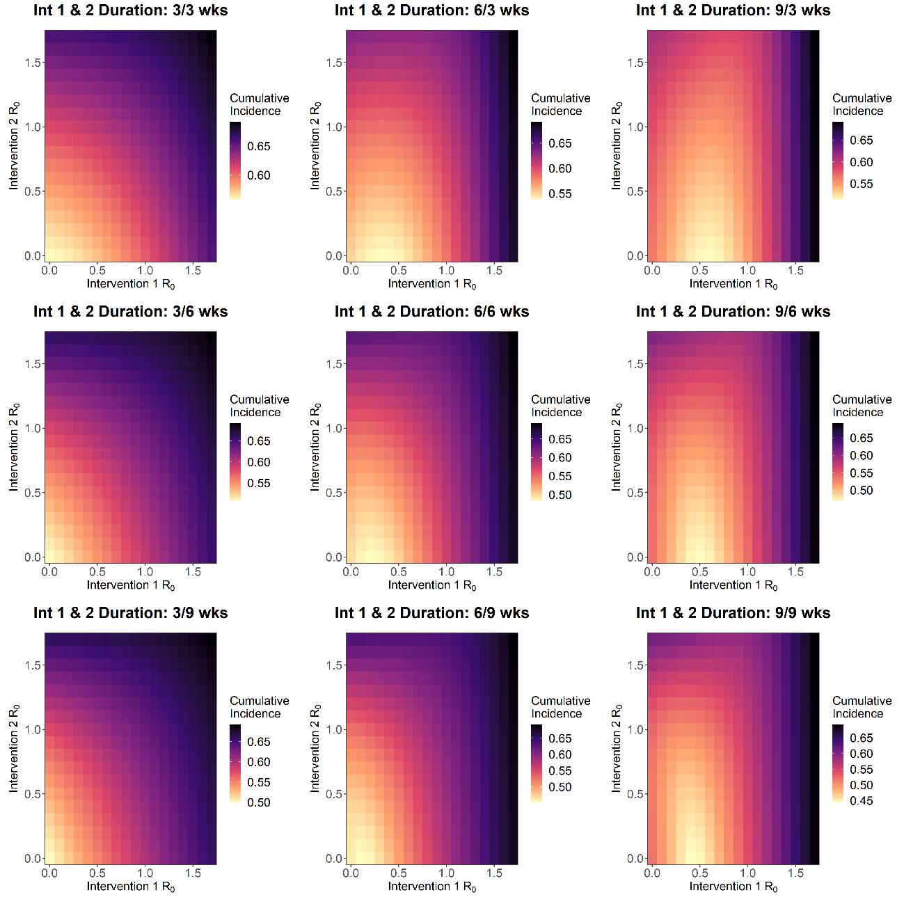

**FIGURE S25 - SCENARIO 4 TOTAL CUMULATIVE INCIDENCE**

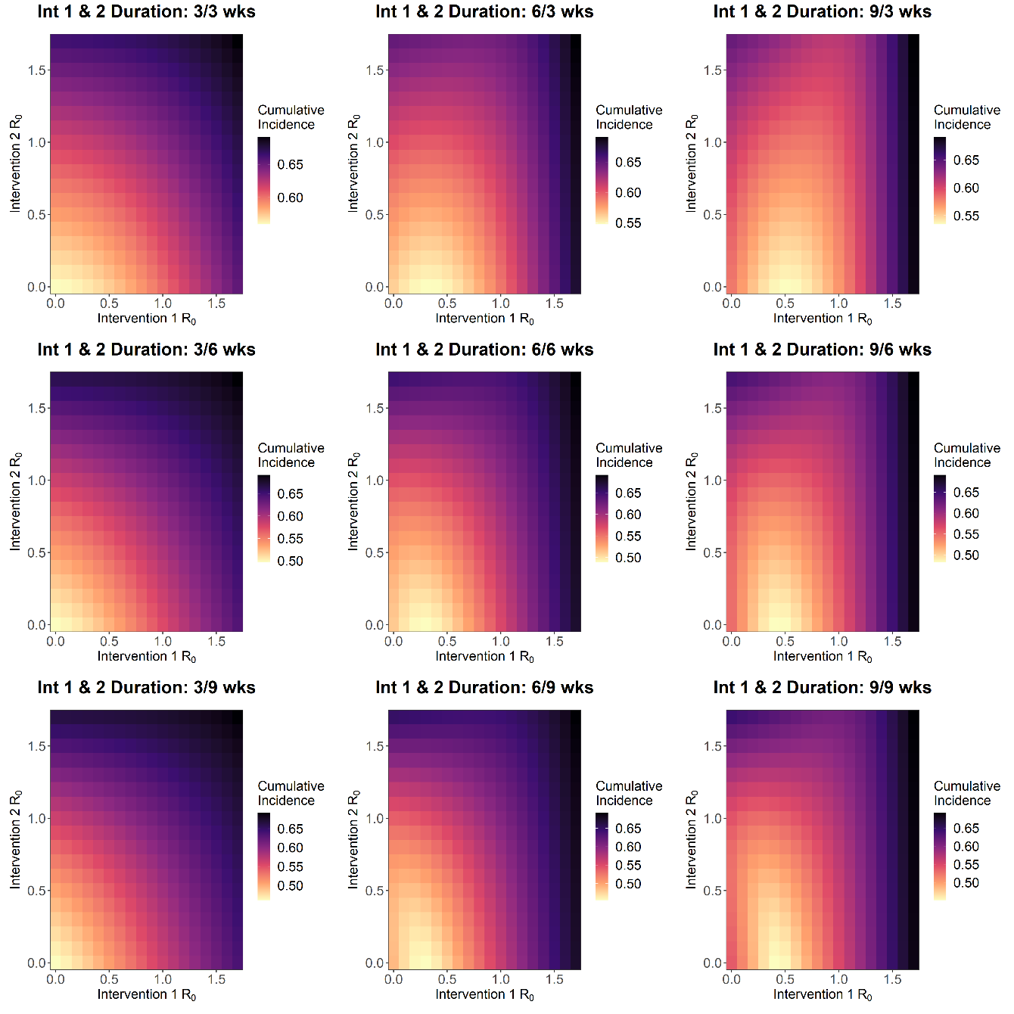

**FIGURE S26 - SCENARIO 5 TOTAL CUMULATIVE INCIDENCE**

**Table S1 – Parameters for the Single Intervention Scenario**

|  |  |  |  |
| --- | --- | --- | --- |
| **Parameter Description** | | **Notation** | **Baseline Value** |
| **Doubling Time** | | **Td** | 3 Days (in line with the recent doubling time estimates) |
| **Baseline Basic Reproduction Number** | | **R0** | 2.8 (unmitigated) to calculate gamma (in line with recent R0 estimates) |
| **Generation Time** | | **G** | 7.8 days |
| **Gamma** | | **γ** |  |
| **Baseline Beta** | | **β** |  |
| **Scaled Beta** | | **βscale** | 30% Reduction to Baseline R0 Beta (roughly R = 1.96 – in line with imperial estimates) |
| Minimum value of c(t) | | **cmin** | 60% Reduction to Mitigated R beta (roughly R = 0.784 – in line with imperial estimates) |
| L**ength of Intervention (Baseline)** | **Scenario 1** | **dt** | 12 weeks |
| **Scenario 2, 3, 4 and 5** | 24 weeks |
| **Trigger Day** | | **tp** | Day 55 (Cumulative Infected = 0.02 at day of lockdown – in line with imperial estimates) |

**Table S1 – Parameters for the Single Intervention Scenario**

|  |  |  |  |
| --- | --- | --- | --- |
| **Parameter Description** | | **Notation** | **Baseline Value** |
| **Doubling Time** | | **Td** | 3 Days (in line with the recent doubling time estimates) |
| **Baseline Basic Reproduction Number** | | **R0** | 2.8 (unmitigated) to calculate gamma (in line with recent R0 estimates) |
| **Generation Time** | | **G** | 7.8 days |
| **Gamma** | | **γ** |  |
| **Baseline Beta** | | **β** |  |
| **Scaled Beta** | | **βscale** | 30% Reduction to Baseline R0 Beta (roughly R = 1.96 – in line with imperial estimates) |
| Minimum value of c(t) – Intervention 1 | | **Cmin1** | 60% Reduction to Mitigated R beta (roughly R = 0.784 – in line with imperial estimates) |
| Minimum value of c(t) – Intervention 2 | | **Cmin2** |  |
| L**ength of Intervention (Baseline) – Intervention 1** | **Scenario 1** | **Dt1** | 12 weeks |
| **Scenario 2, 3, 4 and 5** | 24 weeks |
| L**ength of Intervention (Baseline) – Intervention 2** | **Scenario 1** | **Dt2** |  |
| **Scenario 2, 3, 4 and 5** |
| **Trigger Day – Intervention 1** | | **Tp1** | Day 55 (Cumulative Infected = 0.02 at day of lockdown – in line with imperial estimates) |
| **Trigger Day – Intervention 2** | | **Tp2** | Day 55 (Cumulative Infected = 0.02 at day of lockdown – in line with imperial estimates) |